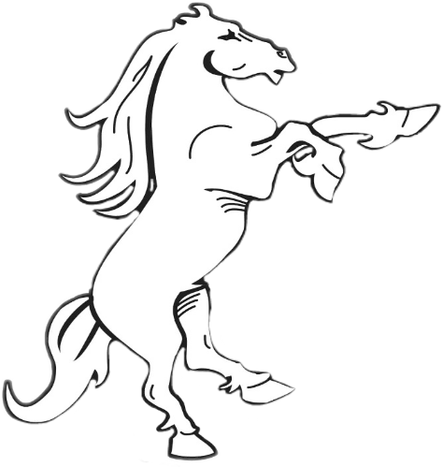
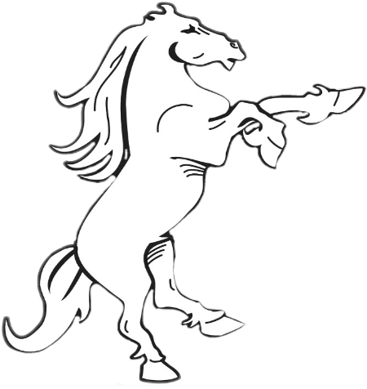
Welcome to Generation Hatton!
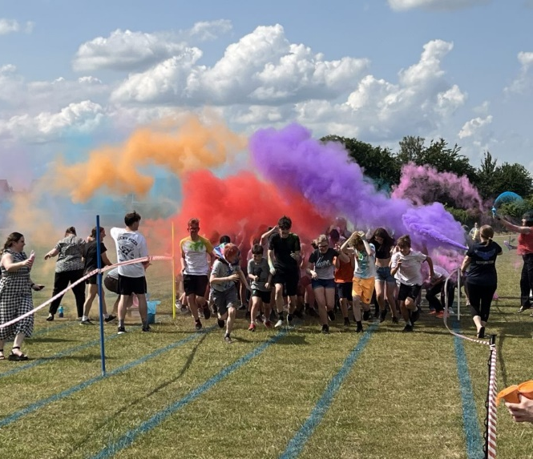
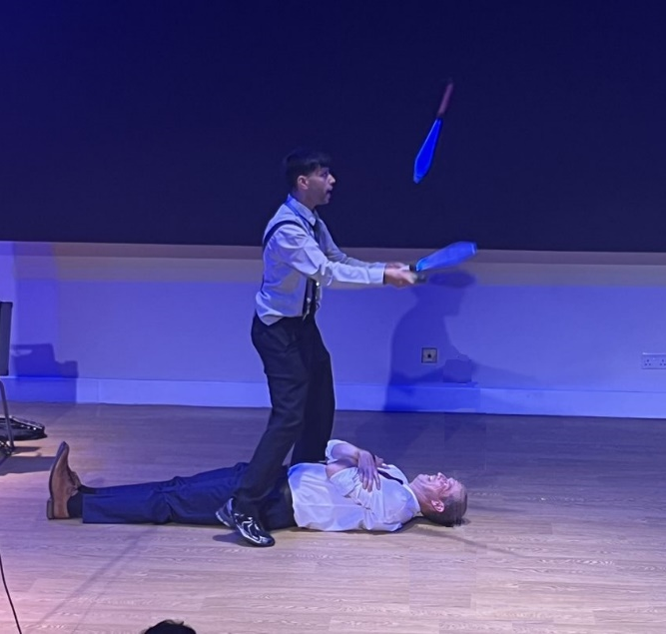
Our team of sixth formers has worked hard to bring you the monthly Generation Hatton Magazine! On our editions page you will find articles, art submissions and quizzes for you to take part in!
We will keep you updated on all things Hatton, from events such as the yearly colour run to Hatton’s Got Talent.
We will also run art competitions and display all the creative and artistic endeavours of Hatton’s students.
Select from our list of editions below!

